NEWS
Material for the March magazine required in the office Sunday 8th February. Could all organisations and groups in the churches please try to send news in or email dianedawson15@gmail.com.

Harvey and Liz’s new address is The Rectory, Badger Lane, Beckbury, Shifnal, TF11 9DG. Harvey is being licensed on February 16th at St. Mary’s Sutton Maddock.

We will be running evening and afternoon Lent Study Groups using Living Faith by Krish Kandiah, based on the Seven Last Words from the Cross. Sign-up sheets for the groups are in church now. Places are limited so please get your name down quickly.

PLACE OF WELCOME Tuesdays at 10.30 - 12.30 in the Parish Centre. Everyone is welcome.

FOOD BANK: Urgently requires tinned ham/spam/corned beef, baked beans, spaghetti hoops, tea and coffee, jams and spreads, tomato sauce and mayonnaise, pasta and rice 500g, dog and cat food.

PRAYING FOR OUR WORLD - The Mission and Ministry Team invite you to join them in prayer in the reading area in Church for their monthly meeting at 7 p.m. on Wednesday 4th February.

SAM, our Musical Director, would like to invite us all to a singing workshop on Sunday 8th February at 12.15 where we will go through the new repertoire pieces together. Details in the magazine.

9 o’clock Morning Prayer is streamed on the Facebook page on Wednesday and Friday
mornings.
Sunday worship on the You Tube page

CHURCH CALENDAR

MONDAY 2nd FEBRUARY
10.00 Clergy Eucharist and Meeting
14.30 St. Oswald’s Ladies Group meet in the
Parish Centre. Speaker Justin Soper
15.00 Funeral of Marlene May Hudspith at
Pentrebychan - Fr. Phil Hughes

TUESDAY 3rd FEBRUARY
10.30 Place of Welcome in Parish Centre

WEDNESDAY 4th FEBRUARY
08.30 Oswestry School Assembly - 0940
09.00 Morning Prayer (online)
10.00 Under 5’s Playgroup - Parish Centre
17.15 Brownies in Parish Centre - 19.15
19.30 Praying for our World - Reading Area
19.30 St. Oswald’s Book Club meet in the Parish
Office
19.30 Scholars and Gentlemen meet in the
Parish Centre

THURSDAY 5th FEBRUARY
10.30 Holy Communion (BCP)
12.30 Funeral of Ann Harding in Church
followed by interment in Oswestry
Cemetery
19.30 Bell ringing practice - 2100

FRIDAY 6th FEBRUARY
09.00 Morning Prayer (online)
19.15 Full Choir - 20.30
20.30 Choral Scholars and Adults - 21.00

SATURDAY 7th FEBRUARY

stoswald.office@gmail.com
http://www.stoswaldsoswestry.org.uk
or follow us on Facebook at:
www.facebook.com/stoswaldsoswestry

THE PARISH CHURCH OF
ST. OSWALD
KING & MARTYR

PRESENTATION OF CHRIST
IN THE TEMPLE
EPIPHANY 4
(Candlemas)
1st February 2026

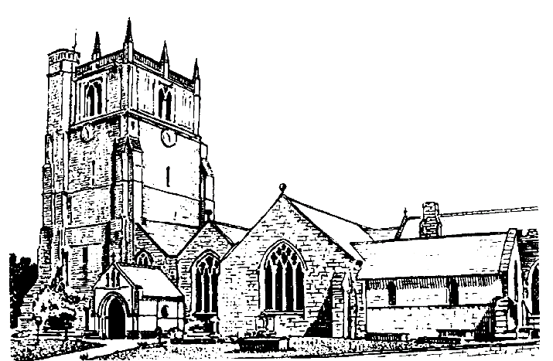

Lord of all life and power, who through the mighty resurrection of your Son overcame the old order of sin and death to make all things new in him: grant that we, being dead to sin and alive to you in Jesus Christ, may reign with him in glory: to whom with you and the Holy Spirit be praise and honour, glory and might now and
in all eternity. Amen

Welcome to worship at St. Oswald’s. Please introduce yourself, especially if you are a visitor or newcomer.

08.00 Holy Communion
President: Rev. Adrian Bailey

10.10 Prayers in St. Catherine’s Chapel

10.30 Parish Eucharist at St. Oswald’s
President: Fr. Phil Hughes

Setting: Archer - St. Albans Service

Processional Hymn: 408

The Collect:
Almighty and ever-living God, clothed in majesty, whose beloved Son was this day presented in the Temple, in substance of our flesh: grant that we may be presented to you with pure and clean hearts, by your Son Jesus Christ our Lord, who is alive and reigns with you, in the unity of the Holy Spirit, one God, now and for ever.

Readings: Malachi 3:1-5
Offering Temple sacrifices while oppressing or neglecting people illustrates tarnished humanity. Before judging us, God will help us, sometimes painfully, to clean up our act.

Psalm - 36 v. 5-10

Hebrews 2:14-end
In Jesus, God shared our human life, understanding our fears and failings. Making the perfect yet painful sacrifice, Jesus frees us from sin and death.

Gradual Hymn: 157

Gospel Luke 2:22-40
Jesus was ritually presented in the Temple as an ordinary human baby, but would offend many by transcending religious practice and reaching out to save all God’s children.

Preacher: Rev. Keith Musson

For your prayers:

Those working to preserve the ceasefire between Israel and Hamas and those working towards peace between Ukraine and Russia.

The people of Greenland and Denmark

The benefices of St. Oswald King & Martyr and Christ Church, Rhydycroesau and the United Benefice of the 6 Parishes as they both begin a new chapter in their mission and ministry

The Church Wardens, PCC, clergy and lay worship teams as they prepare to lead through the vacancy

People struggling with the increases in the cost of living and those who are working to balance the finances of county and local councils

The sick and everyone involved in the medical professions, especially those working for the NHS and in residential and care homes. Also our Home Communion Team as they take out the Holy Sacrament this week and those who they visit.

The families and friends of Ann Harding, Marlene May Hudspith, Barry Johnson, Nigel Rowley, Malcolm Powell and everyone who has recently been bereaved.

Offertory Hymn: 439

Communion Hymn: 295

Anthem: O thou the central orb (Wood)

The Post Communion Prayer:
Lord, you fulfilled the hope of Simeon and Anna, who lived to welcome the Messiah: may we, who have received these gifts beyond words, prepare to meet Christ Jesus when he comes to bring us to eternal life; for he is alive and reigns, now and for ever.

Recessional Hymn: 393

Organ Voluntary: Handel Andante from organ concerto in G major

Please join us for Coffee in the Parish Centre after the service today.

18.00 Sequence of Music & Readings for Candlemas

SUNDAY 8th February - Second Sunday before Lent (Sexagesima)

09.30 Holy Communion at Christ Church Rhydycroesau
President: Fr. Phil Hughes
10.30 Parish Eucharist St. Oswald’s
President: Rev. Adrian Bailey
Preacher: Rev. Adrian Bailey

