NEWS

Material for the October magazine required TODAY 13th September. Could all organisations and groups in the churches please try to send news by email to dianedawson15@gmail.com.

HARVEST LUNCH Sunday October 4th 12.30 in the Parish Centre. Ploughman’s with Apple Crumble as Pudding. Tickets £10 are limited and available from June Williams. 01691652544. Bring your own wine.

PLACE OF WELCOME Tuesdays at 10.30 - 12.30 in the Parish Centre.

FOOD BANK: Urgently requires tinned ham/spam/corned beef, tinned tuna and sardines, biscuits and treats, cereal, shampoo and shower Gel, size 5 and 7 nappies and wet dog food.

Haydn is having a cake stall in the Parish Centre today Sunday September 13th after the service.
All donations to the Debra charity.

PCC MEETING 7 p.m. 14 September in the Parish Centre.

PARISH PROFILE; this has been submitted in preparation for a meeting with the Bishop prior to the placing of an advert for a new incumbent.

Sunday worship on the You Tube page
9 o’clock Morning Prayer is streamed on the Facebook page on Wednesday and Friday

CHURCH CALENDAR
MONDAY 14th SEPTEMBER
19.00 PCC meeting in Parish Centre

TUESDAY 15th SEPTEMBER
10.30 Place of Welcome in Parish Centre -

WEDNESDAY 16th SEPTEMBER
09.00 Morning Prayer (online)
10.00 Under 5’s Playgroup - Parish Centre
17.15 Brownies in the Parish Centre - 19.15
19.30 Scholars and Gentlemen rehearsal in
Parish Centre - 19.00

THURSDAY 17th SEPTEMBER
10.30 Holy Communion BCP
19.30 Bell ringing practice - 2100

FRIDAY 18th SEPTEMBER
09.00 Morning Prayer (online)
19.00 Full Choir - 20.30 in Church
20.30 Choral Scholars and Adults - 21.00

SATURDAY 19th SEPTEMBER
09.00 Oswestry School Founders Day Service -
12.00
15.00 Wedding Jessica Harvey and Christopher
Thomas Jones

stoswald.office@gmail.com
http://www.stoswaldsoswestry.org.uk
follow us on Facebook at:
www.facebook.com/stoswaldsoswestry

THE PARISH CHURCH OF
ST. OSWALD
KING & MARTYR

FIFTEENTH SUNDAY AFTER TRINITY
13TH SEPTEMBER

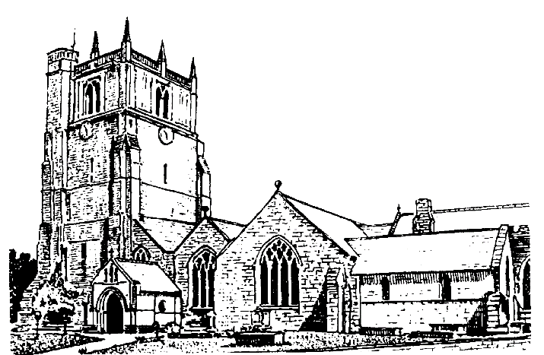

We believe in one God,
Father, Son and Holy Spirit

Welcome to worship at St. Oswald’s. Please introduce yourself, especially if you are a visitor or newcomer.

09.30 Holy Communion at Christ Church Rhydycroesau
President: Fr. Phil Hughes

10.10 Prayers in St. Catherine’s Chapel

10.30 Parish Eucharist at St. Oswald’s

President: Rev. Dr. Keith Musson

Setting: Archer - St. Albans setting

Processional Hymn: 66

The Collect:
God, who in generous mercy sent the Holy Spirit upon your Church in the burning fire of your love: grant that your people may be fervent in the fellowship of the gospel that, always abiding in you, they may be found steadfast in faith and active in service; through Jesus Christ your son our Lord, who is alive and reigns with you in the unity of the Holy Spirit, one God, now and for ever.

Readings - Genesis 50:15-21
Joseph forgives his brothers, recognising that God can bring good out of evil.

Psalm: 114

Romans 14:1-12
Paul urges members of the church in Rome to respect the opinions of others and leave judgement to God.

Gradual Hymn: 393

Gospel Matthew 18:21-35
Jesus teaches that our forgiveness of others should be as limitless as God’s forgiveness of us.

Preacher: Fr. Phil Hughes

For your prayers: For the leaders of the nations that they may seek after ways of peace.

For the people of Iran and other nations in the Middle East and of Sudan.

The victims of the earth quakes in Venezuela, Colombia, Indonesia and flooding in Nepal.
Our young people who have returned to school

The Church Wardens, PCC, clergy and lay worship teams as they lead us.

For all those working in the caring professions and for those in their charge.

The families and friends of Anne Roberts, Peter Davies, Zoe Gillings, Jean Trobridge, Hugh Hughes-Lloyd and everyone who has recently been bereaved.

Offertory Hymn: 436

Communion Hymn: 307

Anthem: Forgive our sins as we forgive - Trad arr. Baldwin

The Post Communion Prayer:
Keep, O Lord, your Church with your perpetual mercy; and, because without you our human frailty cannot but fall, keep us ever by your help from all things hurtful and lead us to all things profitable to our salvation; through Jesus Christ our Lord.

Recessional Hymn: 461

Organ Voluntary: Sortie by Louis James Alfred Lefebure-Wely.

Please join us for Coffee in the Parish Centre after the service today.

6.00 Evening Prayer
Jenifer Chippett Williams
Commissioned Lay Minister

SUNDAY 20th September (Sixteenth Sunday after Trinity)
08.00 Holy Communion at St. Oswalds
President: Rev. Adrian Bailey
10.30 Parish Eucharist
President: Fr. Phil Hughes
Preacher: Rev. Adrian Bailey
Setting: MacMillan - St. Anne’s Mass
Psalm: 105 (v1-6; 37-45}
Anthem: View me Lord, a work of thine - Lloyd
Baptism during service Sean Bacon
Hymns: 104, 357, 361, 302,186
6.00 p.m. Choral Evensong
Jenifer Chippett Williams
Commissioned Lay Minister
Introit: Teach me O Lord - Attwood
Psalm: 119 (v.113 - 136)
Canticle: Stanford in Bb Reponses: Redding
Anthem: Rejoice in the Lord always - Anon.
Hymns: 439, 397, 362

