NEWS

CHURCH CAR PARK
If you are ‘able’ please leave space for those who are less ‘able’

PLACE OF WELCOME Tuesdays at 10.30 - 12.30 in the Parish Centre.

FOOD BANK: Urgently requires tinned ham/spam/corned beef, tinned tuna and sardines, biscuits and treats, cereal, shampoo and shower Gel, size 5 and 7 nappies and wet dog food.

RIDE AND STRIDE is on 12th September this year. Sponsor forms are at the back of the church, or ask annepilsbury@gmail.com. If Riding and Striding is not for you, PLEASE SPONSOR US! We will be visiting some Shropshire churches by car and trying their cakes, if any! Half the money collected goes to Shropshire Historic Churches Trust, who give grants to churches for repairs and improvements. The other half comes back to St Oswald's. Details on our website, or Google:-Shropshire Historic Churches Trust, Ride and Stride.

Invitation to join Oswestry & Borders Foodbank together with Trussell on September 2nd for AGM at 7 p.m. (7.15 start) at Cafe Life in Cabin Lane Church. Good company and refreshments.

St. Oswald’s Ladies Group meet in the Parish Centre on Monday September 7th at 2.30 p.m. when we welcome Julie Dean from Ellesmere Honey Company to speak to us about their Business and their bees.

CHURCH CALENDAR
MONDAY 24th AUGUST

TUESDAY 25th AUGUST

10.30 Place of Welcome in Parish Centre –

WEDNESDAY 26th AUGUST

09.00 Morning Prayer (online)
10.00 Under 5’s Playgroup - Parish Centre
Work on the Piano

THURSDAY 27th AUGUST

10.30 Holy Communion BCP
19.30 Bell ringing practice - 2100

FRIDAY 28th AUGUST

09.00 Morning Prayer (online)

SATURDAY 29th AUGUST

stoswald.office@gmail.com
http://www.stoswaldsoswestry.org.uk
follow us on Facebook at:
www.facebook.com/stoswaldsoswestry
Sunday worship on the You Tube page
9 o’clock Morning Prayer is streamed on the Facebook page on Wednesday and Friday

THE PARISH CHURCH OF
ST. OSWALD
KING & MARTYR

TWELFTH SUNDAY AFTER TRINITY
23RD AUGUST

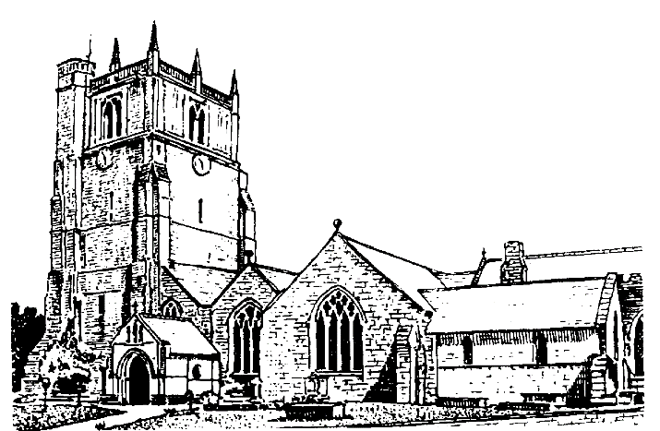

We believe in one God,
Father, Son and Holy Spirit

Welcome to worship at St. Oswald’s. Please introduce yourself, especially if you are a visitor or newcomer.

09.30 Holy Communion at Christ Church Rhydycroesau
President: Rev. Dr. Keith Musson

10.10 Prayers in St. Catherine’s Chapel

10.30 Parish Eucharist at St. Oswald’s
President: Fr. Phil Hughes

Setting: Shephard - Addington Service

Processional Hymn: 385

The Collect:
Almighty and everlasting God, you are always more ready to hear than we to pray and to give more than either we desire or deserve: pour down upon us the abundance of your mercy, forgiving us those things of which our conscience is afraid and giving us those good things which we are not worthy to ask but through the merits and mediation of Jesus Christ your Son our Lord, who is alive and reigns with you, in the unity of the Holy Spirit, one God now and for ever.

Readings - Isaiah 51:1-6
The prophet urges the people to look to the example of their ancestors when they seek the Lord. Heaven and earth will not last, and it is in the Lord alone that they will find comfort and salvation.

Romans 12:1-8
Paul urges his hearers not to follow the ways of the world, but to allow God to renew their minds and hearts so that they may be better able to discern God’s will regarding their lives and their different callings.

Gradual Hymn: 395

Gospel Matthew 16:13-20
Jesus asks his disciples who the people think he is, and hears various answers: John the Baptist, Elijah, one of the prophets. He then asks who they think he is, and Peter gives the divinely inspired answer: ‘You are the Messiah, the Son of the living God.’ Commending Peter, Jesus warns the disciples not to tell anyone.

Preacher: Rev. Dr. Keith Musson

For your prayers: For the leaders of the nations that they may seek after ways of peace.

For the people of Iran and other nations in the Middle East and of Sudan.

The victims of the earth quakes in Venezuela, Colombia and Indonesia.
Our young people who are making important choices about their future studies and their possible employment and those who advise them.

The Church Wardens, PCC, clergy and lay worship teams as they lead us.

For all those working in the caring professions and for those in their charge.

The families and friends of Margaret Stokes, Peter Davies and everyone who has recently been bereaved.

Offertory Hymn: 397

Communion Hymn: 307

The Post Communion Prayer:
God of all mercy, in this eucharist you have set aside our sins and given us your healing: grant that we who are made whole in Christ may bring that healing to this broken world, in the name of Jesus Christ our Lord.

Recessional Hymn: 408

Please join us for Coffee in the Parish Centre after the service today.

12.30 Baptism Rebel Rose Carter
President: Rev. Adrian Bailey

6.00 p.m. Reflective Time
Mrs. Lindsay Clarke
Commissioned Lay Minister

SUNDAY 30th August (Thirteenth Sunday after Trinity)

10.30 Parish Eucharist
President: Rev. Dr. Keith Musson
Preacher: Fr. Phil Hughes
Setting: Shephard – Addington Service
Hymns: 436, 431, 418, 282, 464
12.30 Baptism
Nova Pearl Swannick
NO EVENING SERVICE TONIGHT 30.8.26

