NEWS

THE ANDREW HARRIS TRAINING SUITE for training bell ringers will be dedicated during the 10.30 a.m. Service on the Patronal Festival 2nd August. There will be a visual link so there will be no need to climb the tower.

CHURCH CAR PARK
If you are ‘able’ please leave space for those who are less ‘able’

PLACE OF WELCOME Tuesdays at 10.30 - 12.30 in the Parish Centre.

PATRONAL FESTIVAL - Sunday August 2nd from 12.30 p.m. in the Parish Centre. Please indicate on the sheet at the back of church if you are able to attend and what food you can contribute. Please come and enjoy one another’s company. All are welcome.

FOOD BANK: Urgently requires tinned ham/spam/corned beef, tinned tuna and sardines, biscuits and treats, cereal, shampoo and shower Gel, size 5 and 7 nappies and wet dog food.

Saturday 1st August 2026 Orthodox Service in St. Oswald’s 10 a.m. and then walk to St. Oswald’s well for blessing and return to the Parish Centre for a talk and refreshments at 12.15. All welcome

stoswald.office@gmail.com
http://www.stoswaldsoswestry.org.uk
follow us on Facebook at:
www.facebook.com/stoswaldsoswestry

CHURCH CALENDAR
MONDAY 27th JULY

TUESDAY 28th JULY

10.30 Place of Welcome in Parish Centre - 12.30

WEDNESDAY 29th JULY

09.00 Morning Prayer (online)
10.00 Under 5’s Playgroup - Parish Centre

THURSDAY 30th JULY

10.30 Holy Communion BCP
19.30 Bell ringing practice - 2100

FRIDAY 31st JULY

09.00 Morning Prayer (online)

SATURDAY 1st AUGUST

Saturday 1st August 2026 Orthodox Service in St. Oswalds 10 a.m. and then walk to St. Oswald’s well for blessing and return to the Parish Centre for a talk and refreshments at 12.15. All welcome.

Sunday worship on the You Tube page
9 o’clock Morning Prayer is streamed on the Facebook page on Wednesday and Friday

THE PARISH CHURCH OF
ST. OSWALD
KING & MARTYR

EIGHTH SUNDAY AFTER TRINITY
26TH JULY 2026

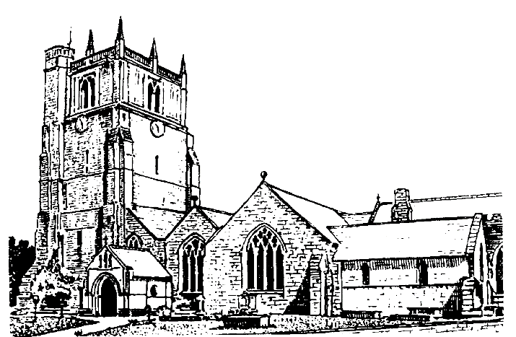

We believe in one God,
Father, Son and Holy Spirit

Welcome to worship at St. Oswald’s. Please introduce yourself, especially if you are a visitor or newcomer.

09.30 Holy Communion at Christ Church Rhydycroesau
President: Fr. Phil Hughes

10.10 Prayers in St. Catherine’s Chapel

10.30 Parish Eucharist at St. Oswald’s
(St. Oswald’s Singers)
President Rev. Dr. Keith Musson

Setting: Shephard Addington Service

Processional Hymn: 449

The Collect:
Almighty Lord and everlasting God, we beseech you to direct, sanctify and govern both our hearts and bodies in the ways of your laws and the works of your commandments; that through your most mighty protection, both here and ever, we may be preserved in body and soul; through our Lord and Saviour Jesus Christ, who is alive and reigns with you, in the unity of the Holy Spirit, one God, now and for ever.

Readings 1 Kings 3:5-12
Offered anything he desires by God, Solomon chooses the wisdom to do right by his people over personal gain, securing the nation for God.

Romans 8:26-end
Paul teaches that the Spirit gives words when prayer is frozen and offers us ways of opening our hearts to that same Spirit’s grace.

Gradual Hymn: 357

Gospel Matthew 13:31-33. 44-52
Jesus describes the kingdom of God as something unprepossessing – tiny, vulnerable and hidden - but which survives and flourishes to grow abundantly and bountifully.

Preacher: Rev. Adrian Bailey

For your prayers:

For the leaders of the nations that they may seek after ways of peace.

For the people of Iran and other nations in the Middle East and of Sudan.

The victims of the earth quake in Venezuela.
Our young people who are making important choices about their future studies and their possible employment and those who advise them.

The Church Wardens, PCC, clergy and lay worship teams as they lead us.

For our young people as they start their summer holidays.

For all those working in the caring professions and for those in their charge.

The families and friends of Bryan Ernest Martin,
John Mellor, Peter Davies, Chris Griffiths and everyone who has recently been bereaved.

Offertory Hymn: 434

Communion Hymn: 276

Anthem: O worship the Lord – J. Travers

The Post Communion Prayer:
Strengthen for service, Lord, the hands that have taken holy things; may the ears which have heard your word be deaf to clamour and dispute; may the tongues which have sung your praise be free from deceit; may the eyes which have seen the tokens of your love shine with the light of hope; and may the bodies which have been fed with your body be refreshed with the fullness of your life; glory to you for ever.

Recessional Hymn: 235

Please join us for Coffee in the Parish Centre after the service today.

12.30 Baptism Ezre George Griffiths
President: Rev. Adrian Bailey

18.00 Reflective Space
Lindsay Clarke - Commissioned Lay Minister

SUNDAY 2nd August (St. Oswald’s Day)
08.00 Holy Communion
President: Rev. Adrian Bailey
10.30 Parish Eucharist
President: Rev. Dr. Keith Musson
Preacher: Fr. Phil Hughes
Setting: Stopford - St. Patricks Eucharist
Anthem: Do not be afraid - Stopford
Hymns: 478, 368 373, 306, 333

6.00 p.m. Choral Evensong
President: Jennifer Chippett Williams
Commissioned Lay Minister

