NEWS
Heating work in church commenced on Monday 22nd of June for approximately 2.5 weeks from
7 a.m.- 7 p.m.

PLACE OF WELCOME Tuesdays at 10.30 - 12.30 in the Parish Centre.

ST. OSWALD’S LADIES GROUP meet in the Parish Centre on Monday 6th July at 2.30 p.m. Speaker Mr. Alan Lewis - His experiences of Metal Detecting.
PRAYING FOR OUR WORLD meet in the Reading Area in Church on Wednesday July 1st at 19.00.
MOTHERS’ UNION FELLOWSHIP GROUP meet in the Parish Centre on Thursday July 9th at 2.15 p.m. Speaker Jan Chesworth.
Clergy Eucharist and Meeting on 6th July at
10 a.m.

Patronal Festival - Sunday August 2nd from 12.30 p.m. in the Parish Centre. Please indicate on the sheet at the back of church if you are able to attend and what food you can contribute. Please come and enjoy one another’s company. All are welcome.

Sunday worship
on the You Tube page
9 o’clock Morning Prayer is streamed on the Facebook page on Wednesday and Friday
stoswald.office@gmail.com
http://www.stoswaldsoswestry.org.uk
or follow us on Facebook at:
www.facebook.com/stoswaldsoswestry

CHURCH CALENDAR
MONDAY 29th JUNE
09.30 Woodside School - 11.15
10.00 Quarter Peal

TUESDAY 30th JUNE
09.30 Woodside School - 11.15
10.30 Place of Welcome in Parish Centre - 12.30

WEDNESDAY 1st JULY
09.00 Morning Prayer (online)
09.30 Woodside School - 11.15
10.00 Under 5’s Playgroup - Parish Centre
14.15 Norma Siegrid Hilde Emmi Brannan -
Cremation at Pentrebychan
17.15 Brownies in the Parish Centre – 19.15
19.00 Praying for our World in the Reading Area
in Church

THURSDAY 2nd JULY
10.30 Holy Communion BCP
19.30 Bell ringing practice - 2100

FRIDAY 3rd JULY
09.00 Morning Prayer (online)
14.00 Oswestry School - (Assembly 2.45) - 4p.m.
16.00 Wedding Rehearsal Nichola and Jeremy
19.00 Full Choir - 20.30 in Church
20.30 Choral Scholars and Adults - 21.00

SATURDAY 4th JULY
10.00 Quarter Peal
14.00 Wedding Nicola Lawrence and Jeremy
Elmhirst

THE PARISH CHURCH OF
ST. OSWALD
KING & MARTYR

FOURTH SUNDAY AFTER TRINITY
28TH JUNE 2026

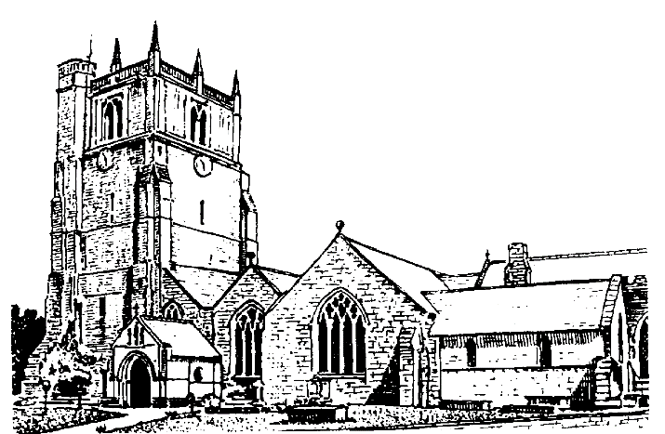

We believe in one God,
Father, Son and Holy Spirit

Welcome to worship at St. Oswald’s. Please introduce yourself, especially if you are a visitor or newcomer.

09.30 Holy Communion at Christ Church Rhydycroesau
President: Fr. Phil Hughes

10.10 Prayers in St. Catherine’s Chapel

10.30 Parish Eucharist at St. Oswald’s

President: Rev. Dr. Keith Musson

Setting: Archer - St. Albans Service

Processional Hymn: 374

The Collect:
O God, the protector of all who trust in you, without whom nothing is strong, nothing is holy; increase and multiply upon us your mercy; that with you as our ruler and guide we may so pass through things temporal that we lose not our hold on things eternal; grant this, heavenly Father, for our Lord Jesus Christ’s sake, who is alive and reigns with you, in the unity of the Holy Spirit, one God, now and for ever.

Readings: Jeremiah 28:5-9
Jeremiah addresses the false prophet Hananiah, warning that prophecies of peace will come to pass only when the Lord has sent a real prophet.

Romans 6:12-end
Paul urges his listeners not to succumb to sinful ways, since they are not under law but under grace. Former slaves to sin have become slaves of righteousness, and God’s free gift is eternal life in Christ.

Gradual Hymn: 237

Gospel: Matthew 10:40-end
Jesus explains that anyone who welcomes one of his disciples receives Jesus himself and, by extension, his heavenly Father. Even the smallest gesture of kindness will be rewarded.

Preacher: Fr. Phil Hughes

For your prayers:
For the leaders of the nations that they may seek after ways of peace.
For the people of Iran and other nations in the Middle East and of Sudan.

Our young people who are making important choices about their future studies and their possible employment and those who advise them.

The Church Wardens, PCC, clergy and lay worship teams as they lead us.

For all those working in the caring professions and for those in their charge.

The families and friends of Bryan Ernest Martin, , Evelyn Anne Wright, Louisa Jane Critchell, George Walter Evans, John Mellor, Norma Siegrid Hilde Emmi Brannan, Peter Davies, Chris Griffiths and everyone who has recently been bereaved.

Offertory Hymn: 475
Communion Hymn: 294

Anthem: Everytime I feel the Spirit - Trad. Arr. Chilcott

The Post Communion Prayer:
Eternal God, comfort of the afflicted and healer of the broken, you have fed us at the table of life and hope: teach us the ways of gentleness and peace, that all the world may acknowledge the kingdom of your Son Jesus Christ our Lord.

Recessional Hymn: 396

Organ Voluntary: Grand Triumphal Chorus by Guilmant.

Please join us for Coffee in the Parish Centre after the service today.

6 p.m. Reflective Space
Pam Willing

SUNDAY 5th July (Fifth Sunday after Trinity)
8 a.m. Holy Communion at St. Oswald’s
President: Rev. Adrian Bailey
10.30 Parish Eucharist at St. Oswald’s
President and Preacher: Fr. Phil Hughes:
Setting: Stopford - St. Patrick’s Eucharist
Anthem: Steal Away - Trad
Hymns: NHWS: 286, 2, 71, 23, 122

18.00 Choral Evensong
President: Jenifer Chippett Williams
Introit: Hail gladdening light - Stainer
Psalm: 56 Canticles: Sumsion in A
Responses: Sumsion
Anthem: Evening Hymn - Balfour Gardiner
Hymns: 376, 252, 239

