**NEWS**

**FOOD BANK:** Urgently requires tinned ham/spam/corned beef, small coffee and tea, tinned spaghetti large tins of sweetcorn, jam and spreads, size 6-7 nappies and pull ups, dog and cat food, shampoo and shower gel.

**ANNUAL GIFT AID REPORTS.**

Letters from the Gift Aid Secretary for all who make donations to the church are available for collection on the table in the south aisle. Please take yours - and those for a friend too.

**PATRONAL FESTIVAL - TODAYSUNDAY AUGUST 3**

Everyone is invited to a BBQ lunch in the Vicarage Garden (Parish Centre if wet) from 12.45pm. If you wish, you are very welcome to bring a bottle to share or consume yourself. If you have a picnic chair or rug, you might want to bring that too.

We look forward to an enjoyable time together; there is plenty of room and ALL are welcome

There will be no coffee in the Parish Centre after

the service on the 3rd August.

The next meeting for Book Club is Monday 4th August at 7.30pm in the Parish Centre; we are reading 'October in the Earth' by Olivia Hawker, and choosing our next book.

***After St. Oswald's day (3rd August) there are no Sunday evening services during August at St. Oswalds.***

**The Rev Harvey Gibbons**

**stoswald.office@gmail.com**

[**http://www.stoswaldsoswestry.org.uk**](http://stoswaldsoswestry.org.uk)

**or follow us on Facebook at:**

[**www.facebook.com/stoswaldsoswestry**](http://www.facebook.com/stoswaldsoswestry)

***CHURCH CALENDAR***

**MONDAY 4TH AUGUST**

10.00  Clergy Eucharist and Meeting

14.30 A very informal get-together in the Parish

Centre on Monday 4th August at 2.30 p.m.

to discuss the Future of the Charity

Christmas Card Shop at St. Oswalds to

have your say. Everyone welcome.

19.30 St. Oswald’s Book Club meet in the Parish

Centre.

**TUESDAY 5TH AUGUST**

10.30 Place of Welcome in Parish Centre

**WEDNESDAY 6TH AUGUST**

09.00 Morning Prayer (online)

10.00 Under 5’s ‘Stay and Play’ Parish Centre

12.30 Thanksgiving service in Church - Stephen

Mosford.

**THURSDAY 7TH AUGUST**

10.30 Holy Communion (BCP)

11.00 Betty Griffiths interment of Ashes at

Oswestry Cemetery.

19.30 Bell ringing practice - 2100

**FRIDAY 8TH AUGUST**

09.00 Morning Prayer (online)

**SATURDAY 9TH AUGUST**

9 o*’clock Morning Prayer is streamed on the Facebook page on Wednesday and Friday mornings. Sunday worship on the You Tube page*

***THE PARISH CHURCH OF***

***ST. OSWALD***

***KING & MARTYR***

**SEVENTH SUNDAY AFTER TRINITY**

**PATRONAL FESTIVAL**

**ST. OSWALD, KING AND MARTYR**

**3rd August 2025**

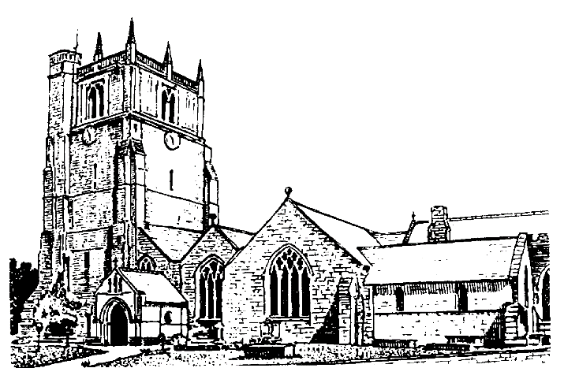

Lord of all life and power, who through the mighty resurrection of your Son overcame the old order of sin and death to make all things new in him: grant that we, being dead to sin and alive to you in Jesus Christ, may reign with him in glory: to whom with you and the Holy Spirit be praise and honour, glory and might now and in all eternity. Amen

Welcome to worship at St. Oswald’s. Please introduce yourself, especially if you are a visitor or newcomer.

**08.00 Holy Communion at St. Oswald’s**

President: Rev. Harvey Gibbons

**10.30 Festive Eucharist**

President: Rev. Harvey Gibbons

Setting: Archer - St. Albans Service

Processional Hymn: 427

**The Collect:**

Lord God Almighty who so kindled the faith of King Oswald with your spirit that he set up the

sign of the cross in his kingdom and turned his

people to the light of Christ: grant that we being fired by the same spirit, may always hear our cross before the world and be founded faithful servants of the Gospel through Jesus Christ your son our Lord who is alive and reigns with you, in the unity of the Holy Spirit, one God now and forever.

**Readings:** Ecclesiastes 1:2. 12-14; 2:18-23

The lot of human beings is an unhappy one. Everything is vanity and chasing after wind. Mortals’ days are full of pain and even at night they cannot rest.

**Psalm: 51 vv 1-8**

Colossians 3: 1-11

We are urged to seek those things that are above and leave behind the ways we once followed. There are no longer differences between us in race or station in life. Christ is in us all.

Gradual Hymn: 463

**Gospel** : Luke 12:13-21

Someone in the crowd asks Jesus to tell his brother to share the family inheritance with him. Jesus uses the question as a way of explaining that being motivated only by the acquisition of money is pointless. In his parable, Jesus tells of a rich man who dies on the very night he is finally satisfied that he has accumulated enough wealth.

**Preacher**: Fr. Phil Hughes

**For your prayers:**

Those working to secure a ceasefire between Israel and Hamas and Ukraine and Russia. Those killed and injured, for all who in bereavement, disability and pain continue to suffer the consequences of war and all who promote peace.

The victims of all forms of abuse especially children and young people and those working to keep them safe from harm.

The sick and everyone involved in the medical professions, especially those working for the NHS and in residential and care homes.

The families and friends of Maureen Crosby, Stephen Mosford, Sylvia West, Barbara Stella Stratford, Betty Griffiths and everyone who has recently been bereaved.

Offertory Hymn: 404 (omit v2)

Communion Hymn: 292

Anthem: Beati quorum via - Stanford

**The Post Communion Prayer:**

Eternal God, who gave us this holy meal in which we have celebrated the glory of the cross and the victory of your martyr Oswald: by our Communion with Christ in his saving death and resurrection give us with all your saints the courage to conquer evil and so to share the fruit of the tree of life; through Jesus Christ our Lord.

Recessional Hymn: 218

**Organ Voluntary:** Leon Boellmann - Toccata from suite Gothique opus 25

***There will be no coffee after the service today in the Parish Centre as the centre will be required for preparing for the Barbecue.***

**6 p.m. Choral Evensong**

President: Rev. Harvey Gibbons

Introit: Locus iste - Bruckner

Canticles: Dyson in D

Responses: Smith

Psalm 72

Anthem: Te Deum in B flat - Stanford

Hymns: 217, 449, 216

**SUNDAY 10th AUGUST** - **Eighth Sunday after Trinity**

10.30 **Parish Eucharist** at St. Oswald’s

President: Rev. Keith Musson

Preacher: Rev. Harvey Gibbons

**No service at 6 p.m. at St. Oswald’s**

**Holy Communion at Christ Church Rhydycroesau at 9.30 a.m. on 10th August**

**President: Fr. Phil Hughes**