NEWS
Material for the October magazine required 13th September. Could all organisations and groups in the churches please try to send news by email to dianedawson15@gmail.com.

HARVEST LUNCH Sunday October 4th 12.30 in the Parish Centre. Tickets are limited and available from June Williams. 01691652544

St. Oswald’s Ladies Group meet in the Parish Centre on Monday September 7th at 2.30 p.m. when we welcome Julie Dean from Ellesmere Honey Company to speak to us about their Business and their bees.

PLACE OF WELCOME Tuesdays at 10.30 - 12.30 in the Parish Centre.

FOOD BANK: Urgently requires tinned ham/spam/corned beef, tinned tuna and sardines, biscuits and treats, cereal, shampoo and shower Gel, size 5 and 7 nappies and wet dog food.

Thursday 10th September Pam Musson is hosting a Mothers` Union QUIET DAY from 11 a.m. for 11.15 a.m. start in the Parish Centre finishing at 15.30.

RIDE AND STRIDE 12th September. Sponsor forms are at the back of the church, or ask annepilsbury@gmail.com. Half the money collected goes to Shropshire Historic Churches Trust, who give grants to churches for repairs and improvements. The other half comes back to St Oswald's.
Sunday worship on the You Tube page
9 o’clock Morning Prayer is streamed on the Facebook page on Wednesday and Friday

CHURCH CALENDAR
MONDAY 7th SEPTEMBER
08.30 Oswestry School - 10.30
10.00 Clergy Eucharist and Meeting
14.30 St. Oswald’s Ladies Group meet in the
Parish Centre. Speaker Julie Dean.

TUESDAY 8th SEPTEMBER
10.30 Place of Welcome in Parish Centre -

WEDNESDAY 9th SEPTEMBER
09.00 Morning Prayer (online)
10.00 Under 5’s Playgroup - Parish Centre
14.00 Memorial Service in Church Anne Marie
Roberts - Rev. David North
17.15 Brownies in the Parish Centre - 19.15
19.30 Scholars and Gentlemen rehearsal in
Parish Centre - 19.00

THURSDAY 10th SEPTEMBER
10.30 Holy Communion BCP
11.00 Mothers` Union QUIET DAY from 11 a.m.
19.30 Bell ringing practice - 2100

FRIDAY 11th SEPTEMBER
09.00 Morning Prayer (online)
19.00 Full Choir - 20.30 in Church
20.30 Choral Scholars and Adults - 21.00

SATURDAY 12th SEPTEMBER
RIDE AND STRIDE FOR CHURCHES
16.15 Visiting bell ringers quarter peal - 17.00

stoswald.office@gmail.com
http://www.stoswaldsoswestry.org.uk
follow us on Facebook at:
www.facebook.com/stoswaldsoswestry

THE PARISH CHURCH OF
ST. OSWALD
KING & MARTYR

FOURTEENTH SUNDAY AFTER TRINITY
6TH SEPTEMBER

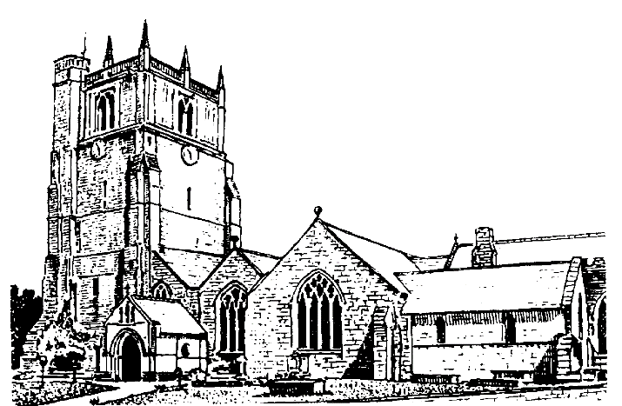

We believe in one God,
Father, Son and Holy Spirit

Welcome to worship at St. Oswald’s. Please introduce yourself, especially if you are a visitor or newcomer.

08.00 Holy Communion
President: Rev. Adrian Bailey

10.10 Prayers in St. Catherine’s Chapel

10.30 Parish Eucharist at St. Oswald’s
St. Oswald’s Singers

President: Fr. Phil Hughes

Setting: Shephard - Addington Service

Processional Hymn: 186

The Collect:
Almighty God, whose only Son has opened for us a new and living way into your presence: give us pure hearts and steadfast wills to worship you in spirit and in truth; through Jesus Christ your Son our Lord, who is alive and reigns with you, in the unity of the Holy Spirit, one God, now and for ever.

Readings - Ezekiel 33:7-11
Ezekiel learns from God that he shares responsibility for the sin of the people. It is his duty to speak of their transgressions and call them to repentance.

Romans 13:8-end Paul encourages his readers to live new lives in Jesus, reminding them of his command to love one another.

Gradual Hymn: 464

Gospel: Matthew 18:15-20
Jesus provides a model for the forgiveness of sinners as part of the life of a functioning church community, and an assurance that he will be present when two or three people gather together.

Preacher: Rev. Dr. Keith Musson

For your prayers: For the leaders of the nations that they may seek after ways of peace.

For the people of Iran and other nations in the Middle East and of Sudan.

The victims of the earth quakes in Venezuela, Colombia, Indonesia and flooding in Nepal.
Our young people who have returned to school
this week.

The Church Wardens, PCC, clergy and lay worship teams as they lead us.

For all those working in the caring professions and for those in their charge.

The families and friends of Anne Roberts, Peter Davies, Zoe Gillings, Jean Trobridge, Hugh Hughes-LLoyd and everyone who has recently been bereaved.

Offertory Hymn: 490

Communion Hymn: 288

Anthem: I give you a new commandment - Anon

The Post Communion Prayer:
Lord God, the source of truth and love, keep us faithful to the apostles’ teaching and fellowship, united in prayer and the breaking of bread, and one in joy and simplicity of heart, in Jesus Christ our Lord.

Recessional Hymn: 265

Please join us for Coffee in the Parish Centre after the service today.

Evening Prayer
Jenifer Chippett Williams
Commissioned Lay Minister

SUNDAY 13th September (Fifteenth Sunday after Trinity)
09.30 Holy Communion at Christ Church Rhydycroesau
President: Fr. Phil Hughes

10.30 Parish Eucharist
President: Rev. Dr. Keith Musson
Preacher: Fr. Phil Hughes
Setting: Archer - St. Albans setting
Anthem: Forgive our sins as we forgive - Trad arr. Baldwin

6.00 p.m. Evening Prayer
Jenifer Chippett Williams
Commissioned Lay Minister

