NEWS

Material for the September magazine required 16th August. Could all organisations and groups in the churches please try to send news by email to dianedawson15@gmail.com.

CHURCH CAR PARK
If you are ‘able’ please leave space for those who are less ‘able’

PLACE OF WELCOME Tuesdays at 10.30 - 12.30 in the Parish Centre.

FOOD BANK: Urgently requires tinned ham/spam/corned beef, tinned tuna and sardines, biscuits and treats, cereal, shampoo and shower Gel, size 5 and 7 nappies and wet dog food.

RIDE AND STRIDE is on 12th September this year. Sponsor forms are at the back of the church, or ask annepilsbury@gmail.com. If Riding and Striding is not for you, PLEASE SPONSOR US! We will be visiting some Shropshire churches by car and trying their cakes, if any! Half the money collected goes to Shropshire Historic Churches Trust, who give grants to churches for repairs and improvements. The other half comes back to St Oswald's. Details on our website, or Google:-Shropshire Historic Churches Trust, Ride and Stride.

stoswald.office@gmail.com
http://www.stoswaldsoswestry.org.uk
follow us on Facebook at:
www.facebook.com/stoswaldsoswestry

CHURCH CALENDAR
MONDAY 10th AUGUST

TUESDAY 11th AUGUST

10.30 Place of Welcome in Parish Centre – 14.30 Mothers’ Union Fellowship Group meet at
St. Andrews Church, Welsh Frankton
to celebrate 150 years of Mothers’ Union.

WEDNESDAY 12th AUGUST

09.00 Morning Prayer (online)
10.00 Under 5’s Playgroup - Parish Centre
15.00 Renewal of Wedding vows Louise Perry

THURSDAY 13th AUGUST

10.30 Holy Communion BCP
19.30 Bell ringing practice - 2100

FRIDAY 14th AUGUST

09.00 Morning Prayer (online)

SATURDAY 15th AUGUST

10.30 Wedding - Freya Sands and Thomas
Fearon

Sunday worship on the You Tube page
9 o’clock Morning Prayer is streamed on the Facebook page on Wednesday and Friday

THE PARISH CHURCH OF
ST. OSWALD
KING & MARTYR

TENTH SUNDAY AFTER TRINITY
9TH AUGUST

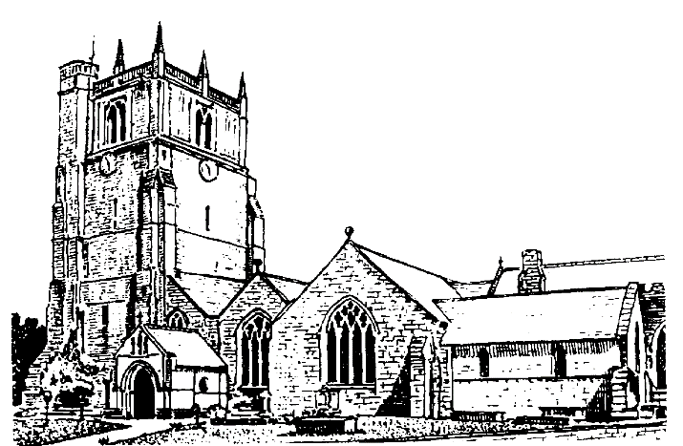

We believe in one God,
Father, Son and Holy Spirit

Welcome to worship at St. Oswald’s. Please introduce yourself, especially if you are a visitor or newcomer.

09.30 Holy Communion at Christ Church Rhydycroesau
President: Fr. Phil Hughes

10.10 Prayers in St. Catherine’s Chapel

10.30 Parish Eucharist at St. Oswald’s
President Rev. Adrian Bailey

Setting: Shephard - Addington Service

Processional Hymn: 443

The Collect:
Let your merciful ears, O Lord be open to the prayers of your humble servants, and that they may obtain their petitions make them to ask such things as shall please you; through Jesus Christ your Son our Lord, who is alive and reigns with you, in the unity of the Holy Spirit, one God, now and for ever.

Readings - 1 Kings 19:9-18
A fearful and faithless Elijah is paralysed by the enormity of the task ahead of him. He remonstrates with God but is unmoved by God’s demonstration of power and authority. God asks Elijah to find others to help him complete the tasks he has been called to do.

Romans 10:5-15
Paul makes it clear that fulfilment of the law is not blind obedience, but submission to Christ. This is a gift that is open to all: ‘Everyone who calls on the name of the Lord shall be saved.’

Gradual Hymn: 336

Gospel: Matthew 14:22-33
Jesus sends the disciples away to sail across the lake. He leaves them overnight to fend for themselves in the storm. Their faith is tested. Only when they see Jesus walk on water and rescue Peter from drowning do they recognise him as the Son of God.

Preacher: Rev. Dr. Keith Musson

For your prayers: For the leaders of the nations that they may seek after ways of peace.

For the people of Iran and other nations in the Middle East and of Sudan.

The victims of the earth quake in Venezuela.
Our young people who are making important choices about their future studies and their possible employment and those who advise them.

The Church Wardens, PCC, clergy and lay worship teams as they lead us.

For all those working in the caring professions and for those in their charge.

The families and friends of Peter Davies, Chris Griffiths and everyone who has recently been bereaved.

Offertory Hymn: 383

Communion Hymn: 312

The Post Communion Prayer:
God of our pilgrimage, you have willed that the gate of mercy should stand open for those who trust in you: look upon us with your favour that we who follow the path of your will may never wander from the way of life; through Jesus Christ our Lord.

Recessional Hymn: 354

Organ Voluntary:

Please join us for Coffee in the Parish Centre after the service today.

6.00 p.m. Evening Prayer
President: Mrs. Jennifer Chippett Williams
Commissioned Lay Minister

SUNDAY 16th August (Eleventh Sunday after Trinity)
08.00 Holy Communion
President: Fr. Phil Hughes
10.30 Parish Eucharist
President: Fr. Phil Hughes
Preacher: Fr. Phil Hughes
Setting: Shephard - Addington Service
Hymns: 374, 379, 391, 296, 377

6.00 p.m. Evening Prayer
President: Mrs. Jennifer Chippett Williams
Commissioned Lay Minister

